Subaward Invoice Checklist
Required Invoice Elements
  - Subaward Number - (Grant Code + Index) check that it matches the Subaward Agreement number
  - Invoice Number – included in Subrecipients sequentially numbered invoicing convention
  - Invoice Period - Dates the costs were incurred
  - Invoice Amount
  - Subrecipient Name and Address
  - Expense Breakdown by Major Cost Category – Identifies all costs being requested for reimbursement
  - Current and Cumulative Costs
  - Cost Share Expenses - Current and Cumulative (if applicable)
  - Subrecipient Signature - The invoice must be signed by the subrecipient’s authorized official.
  - Subrecipient Certification –
Since ISGC & INE awards are federally sponsored, the following subrecipient certification language must be on the invoice:

By signing this report, I certify to the best of my knowledge and belief that the report is true, complete, and accurate, and the expenditures, disbursements and cash receipts are for the purposes and objectives set forth in the terms and conditions of the Federal award. I am aware that any false, fictitious, or fraudulent information, or the omission of any material fact, may subject me to criminal, civil or administrative penalties for fraud, false statements, false claims or otherwise. (U.S. Code Title 18, Section 1001 and Title 31, Sections 3729-3730 and 3801-3812).

Please see the ISGC/INE Invoice Template for an example.

Supporting Documentation
Your risk level (assigned by University of Idaho Office of Sponsored Programs) determines whether you must include the following with your invoice. If you are not sure of your risk level, please contact isgc@uidaho.edu
- Transaction Detail Report
  - Please make sure there is traceability between the invoice and the detail report.
- Payroll Report (If requesting reimbursement for salaries/wage & fringe benefit expenses)
  - Please make sure the total of salaries/wage and fringe expenses tie to the total amount reported in those major cost categories on the invoice.
- Pay Stub for Employee Rate Verification (only required for the first reimbursement per individual to verify rate of pay)
  - Sensitive information should be redacted (i.e. social security number, home address, banking numbers, etc.)
- Source Documents for Each Non-Payroll Transaction (receipts, vendor invoices, etc.)
  - This should align with the Transaction Detail Report?
- Sam.gov Vendor Verification (for each vendor)
  - Include a Sam.gov report for each vendor paid.
  - If a vendor cannot be found in Sam.gov a screenshot of the “No matches found” result will suffice.

How to document/get the attached out of SAM.GOV
- Use the search function in SAM and enter the vendor name.
- From this screen click on vendor profile, (their name in blue is the link)
- Once in their profile click the actions button in the top right corner and then click download and that will give you the attached page.
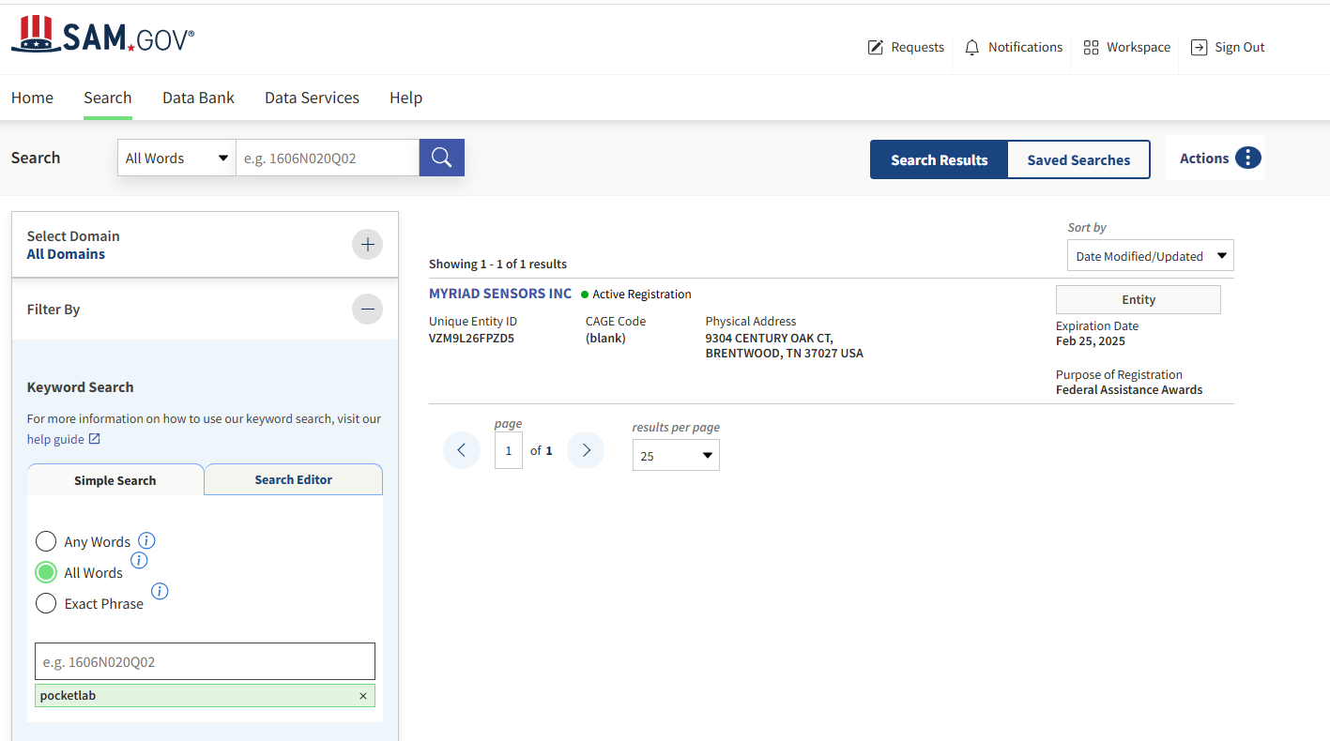

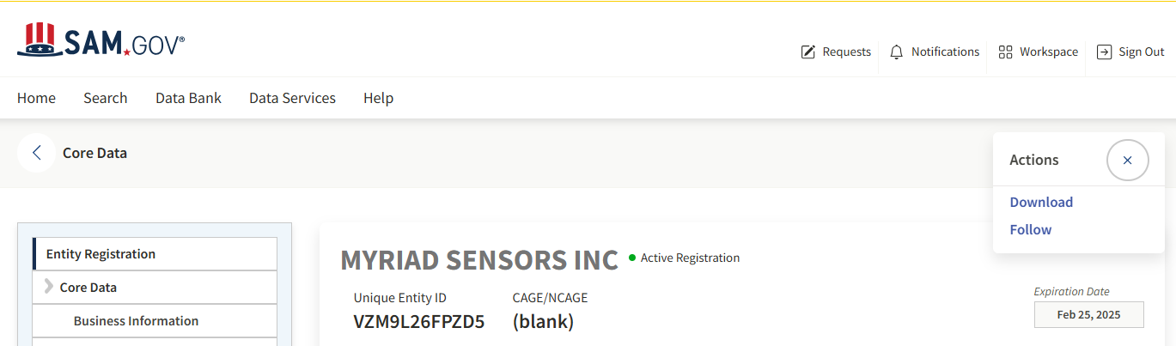

See below for an example of a vendor that does not have a profile. Please print out this page. The best way to print this page is to just ctrl P.
